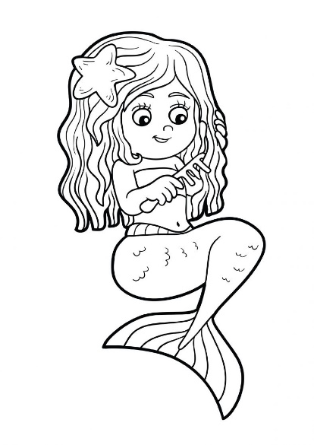


Starters - £4
Hummus and crudites
Halloumi Fries
Buttermilk Chicken Goujons
Menu - £7
Ham, Egg and Chips
Cheese Burger or Chicken Burger & Chips with salad or peas
Vegetable skewers with pitta and salad
Cheese and tomato linguine
Fish Fingers & Chips with salad or peas
Dessert - £4
Freddo Chocolate Sundae
Strawberry Sundae
Chocolate brownie

